Solar Paint: The Future of Ecofriendly and Economically Renewable energy
Ved Kumar¹ and Bharat Raj Singh^{1,2}, Pramod Kumar Singh¹
¹Department of Humanities and Applied Sciences
²Director General Technical, School of Management Sciences
¹School of Management Sciences Lucknow, Uttar Pradesh, India
E-mail: vedchem21@gmail.com

Abstract: Solar paint also referred to as photovoltaic or photoactive paint is an emerging technology engineered to efficiently convert sunlight into electricity. Utilizing advanced nanomaterial, semiconductors, and conductive polymers, solar paint solution provides a low-cost, flexible, and highly scalable method for energy generation. These innovative coatings can be applied to various surfaces, transforming walls, roofs, and even vehicles into active power-generating systems. While the solar paint technology demonstrates immense potential due to its adaptability and economic manufacturing profile, improving its power conversion efficiency remains a critical challenge, requiring further research into optimal material compositions. This study explores the fundamental principles of solar energy conversion, examines the roles of nanomaterial and photoactive layers, and evaluates methods for fabricating and assessing the performance of solar paints. The primary objective of this research is to identify and develop optimal paint materials capable of delivering higher electrical and thermal conductivities alongside improved overall efficiency.
Keyword: Solar Paint, Nanomaterial, Semiconductor, Ecofriendly, Economically

- INTRODUCTION
As global energy demands continue to rise, renewable energy sources have emerged as a critical mechanism for sustainable development. Current reports indicate that approximately 85% of the world's energy consumption is still reliant on fossil fuels. Nevertheless, the transition toward renewables is essential for mitigating climate risks and achieving net-zero emissions by 2050 (1, 2). In fact, projections from the International Renewable Energy Agency (IRENA) suggest that green energy technologies could account for nearly 90% of the global electricity supply by 2050 (3). Installing solar panels is an expensive and labor-intensive process, which is why they are not commonly found on the homes of average people. But what if cheap and easy methods for generating solar energy were discovered one that the common person could readily use. Solar paint that can be applied to any surface; it captures energy from the sunlight and converts it into electricity shown in figure 1. While it resembles ordinary paint, it contains billions of particles of light-sensitive material. It is this material that transforms standard paint into a highly efficient, energy-capturing coating. For owners of homes, factories, or commercial properties, the best feature of solar paint is that it is both easy and affordable to apply. Unlike traditional solar panels, it does not require an entire installation team spending the day working on your roof.
Essential Concepts and Fundamentals of solar paints explore the science, design, and application of energy-harvesting coatings that convert sunlight into electricity. Solar paints also called photovoltaic or photoactive paints leverage nanomaterials, semiconductors, and conductive polymers to create low-cost, flexible, and scalable solar energy solutions.
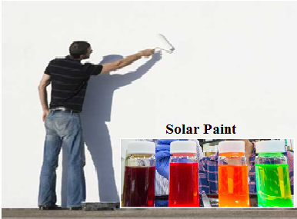
Figure.1 Solar Paint on the wall
These innovative coatings can be applied to different types of surfaces, like turning walls, roofs, and even vehicles into power-generating systems. In this research, learners will examine the principles of solar energy conversion in paint-based systems, the role of particles of nanomaterial and photoactive layers, and the fabrication and performance evaluation of solar paints. Researchers will gain both theoretical knowledge and practical insight into the emerging field of solar paint and their potential to advance sustainable and solar power energy (3).
Solar paint is still in the development and research phase, with current efficiencies for some types hovering around 8% to 10%, making it not yet widely commercially viable (3). Figure 2 illustrates the core concepts of solar paints also known as photovoltaic or photoactive paints, which are energy-harvesting coatings that convert sunlight into electricity. By utilizing nanomaterial, semiconductors, and conductive polymers, these paints offer a low-cost, flexible, and scalable approach to generating solar energy.

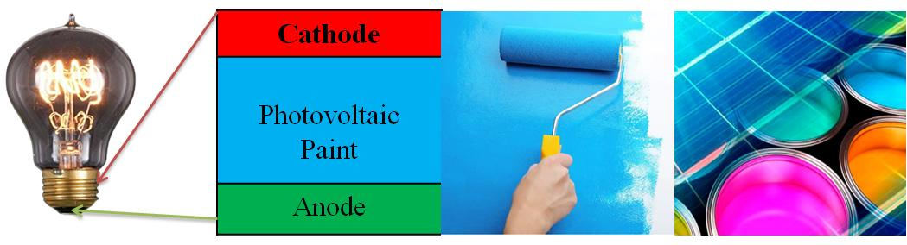
Figure.2 Solar Paint on surface to generate electric power
Solar paint captures sunlight and converts it into electricity. Solar paint has special materials like titanium oxide or titanium oxide. These materials take sunlight and change it into electric current. Explore the different types of materials used in solar paints, including semiconductors, nanomaterial, and conductive inks. Learn about the fabrication techniques for preparing solar paints and their application on various surfaces. Examine the current challenges in solar paint technology, including efficiency, stability, and scalability. Study real-world applications of solar paints in buildings, vehicles, and wearable technology. Gain knowledge on the environmental and economic benefits of solar paints as an alternative renewable energy source.
- PRINCIPLE OF SOLAR ENERGY
Solar paint is an emerging photovoltaic technique that enables energy harvesting through a liquid past or sprayable coating applied to various surfaces. Unlike conventional solar panels, which use rigid silicon-based cells, solar paint is designed to be flexible, lightweight, and applicable to a wide range of structures such as walls, roofs, vehicles, portable devices and road-bridge dividers. The basic principle of solar paint with a thin film architecture can be defined as when sunrays strikes the light absorbing substances (photo electrode), electrons of photo electrode gains energy and the drifted electron with high-energy into a layer of paint like substance, leaving behind an electron vacancy. Then the electrode collected the electron and power is produced using the energy from the electron (4).
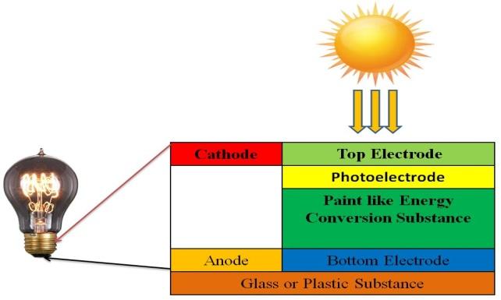
Fig.3 Schematic diagram of thin film photovoltaic paint
This drift of electrons completes the circuit by combining with electron valances, as illustrated in figure 3. Solar paint can also combine the sensitizer and the wide band-gap semiconductor into a single layer. The power conversion in solar cells depends on the principle of the photovoltaic effect. Photons with energy greater than the band gap energy (Eg) are absorbed, causing electrons to be excited from the valence band to the conduction band. Solar cells have an inherent asymmetry that drives electrons toward the external circuit by generating an electrical potential.
For getting better efficiency, we need stability on Open circuit voltage (Voc), Short circuit current density (Isc) and fill factor (FF). These parameters are directly related to improvement of efficiency.
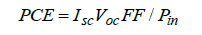
Where, VOC : Open circuit voltage,
ISC: Short circuit (photo) current,
FF: Fill factor (It is a ratio of actual maximum obtainable power to the product of the open circuit voltage and short circuit current.
Defined as the product of ISC and VOC and is also a measure of the square of (I-V profile). Efficiently extraction of electrons and holes is the most important key parameter for highly efficient solar paint or solar cell. Solar paint performance is determined by the measurement of current density as the voltage across the photovoltaic device is biased with the variable load during the insulation of device. Figure 5 depicts the plotting of energy versus temperature (5). As the energy of photon is inversely proportional to the wavelength 1240/λ[nm]); Therefore, the value of short circuit current (ISC) depends on the value of band gap energy Eg.
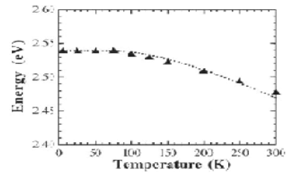
Figure 4. Plotting of energy vs temperature
If the value of E is greater than the value of Eg and the solar spectrum is over the visible and infra-red regions, then generally the ISC factor increases with the increasing λ . Even though power conversion efficiency (PCE) increases with ISC, there is also an existence of optimum value of Eg for attaining significant PCE because of the trade-off associated with VOC. The band gap energy (Eg) required achieving optimum power conversion efficiency ranges from 1.0 to 1.6 eV for the crystalline silicon solar cell. However, photovoltaic paint requires band gap energy (Eg) ranging from 0.6 to 1.1 eV to achieve optimum power conversion efficiency through utilizing multiple excitation generation. With the increase of thickness of the film there is an exponential decrease in the absorption of light intensity (5).
- PREPARATION OF SOLAR PAINT
Solar paint is prepared by formulating a light-sensitive mixture that can absorb sunlight and convert it into electrical energy after application on a surface. The preparation mainly involves selecting suitable photoactive materials, dispersing them in a solvent system, and creating a stable coating formulation. First, semiconductor nanoparticles or photoactive materials such as titanium dioxide (TiO₂), cadmium sulfide (CdS), cadmium selenide (CdSe), perovskite compounds, or carbon-based quantum dots are synthesized. These materials act as the primary light-absorbing components
The production of quantum dot (QD)-sensitized photo anodes, especially the deposition of quantum dot on TiO₂ matrix, is usually a time-extensive and performance-determinant step in the construction of QD-sensitized solar cells (QDSCs). Herein, a transformative approach for immobilizing QD on the TiO₂ matrix was developed by simply mixing the as-prepared oil-soluble QDs with TiO₂ particles suspension for a period as short as half a minute. The solar paint was prepared by adding the TiO₂/QD composite in a binder solution under ultrasonic agitator. The QD-sensitized photoanodes were then obtained by simply brushing the solar paint on a fluorine-doped tin oxide substrate followed by a low-temperature annealing at ambient atmosphere. Sandwich-structured complete QDSCs were assembled with the use of Cu₂S/brass as counter electrode and polysulfide redox couple as an electrolyte (6).
The photovoltaic performance of the resulting Zn–Cu–In–Se (ZCISe) quantum dot-sensitized solar cells (QDSCs) was evaluated after optimizing the QD/TiO₂ ratio and the thickness of the photoanode films. Using this proof-of-concept solar paint approach for fabricating photoanode films, an average power conversion efficiency (PCE) of 4.13% was achieved under standard irradiation conditions, with a short-circuit current density Jsc​ = 11.11 mA/cm², an open-circuit voltage Voc​ = 0.590 V, and a fill factor (FF) of 0.631 (7). This simple and efficient solar paint technique provides a convenient method for fabricating quantum dot (QD)-sensitized photoanodes for use in quantum dot-sensitized solar cells (QDSCs). Furthermore, the versatility of solar paint enables energy harvesting from a wide variety of surfaces, including walls, roller blinds, umbrellas, curtains, and tents. This adaptability distinguishes solar paint from conventional solar energy technologies and highlights its potential for diverse practical applications (8).
- RESULTS AND DISCUSSION
The level of efficiency of the third generation solar cells is lagging to achieve comparable with other generations table 1.Therefore, the materials which will be used for solar paint is a critical factor towards the enhancement of efficiency. Each material has its own attractive features. However, the selection of each material associates with the availability of raw materials and adequate manufacturing process. Most photovoltaic paints are developed using second- and third-generation solar cell materials. Among the various technologies, tandem solar cells integrated with quantum dot-sensitized solar cells (QDSSCs) are particularly attractive because their band gap can be tuned by controlling the size of the quantum dots. This tunable band-gap property allows for better absorption of different wavelengths of sunlight and can enhance overall device performance. In contrast, conventional bulk materials such as copper indium gallium selenide (CIGS) and cadmium telluride (CdTe) possess fixed band-gap energies that are determined by their intrinsic material composition.
Table 1 Best Research Solar Cell Efficiency of different Solar cell

S.No | Generation | Solar cell | Efficiency %
1 | First | Crystalline Silicon | 29.7±0.5
2 | First | Multi Crystalline Silicon | 22.3±0.4
3 | Second | Amorphous Silicon | 14.0±0.4
4 | Second | Micro Crystalline Silicon | 11.9±0.3
5 | Third | Dye Sensitized cell | 11.9±0.4
6 | Third | Organic (Thin Film) | 11.2±0.3
7 | Third | Perovskit (Thin Film) | 22.7±0.3
8 | Third | Quantum Dot Sensitized | 22.7±0.3
9 | Fourth* | Nanoparticles/ Quantum Dot | 8-10±0.5

Therefore, the materials which will be used for solar paint is a critical factor towards the enhancement of efficiency. Each material has its own attractive features. However, the selection of each material associates with the availability of raw materials and adequate manufacturing process. Most photovoltaic paints are developed using second- and third-generation solar cell materials. Among the various technologies, tandem solar cells integrated with quantum dot-sensitized solar cells (QDSSCs) are particularly attractive because their band gap can be tuned by controlling the size of the quantum dots. This tunable band-gap property allows for better absorption of different wavelengths of sunlight and can enhance overall device performance. In contrast, conventional bulk materials such as copper indium gallium selenide (CIGS) and cadmium telluride (CdTe) possess fixed band-gap energies that are determined by their intrinsic material composition.
A combination of quantum dot with perovskite likewise upgrades the charge carrier extraction in collecting layer of Quantum dot solar powered cell. Solar cell additionally give the adaptability of conveying high accuse transporters of the capacity to permit electrons to travel all the more longer distance absent a lot of loss of energy. A gathering of Organic solar cell likewise offers a lot less expensive and less complex photovoltaic with an impulse of activity solidness in high temperature climate. What's more, a material comprised of Copper zinc tin sulphide (CZTS) likewise satisfies the material prerequisite for arrangement processable photovoltaic paints yet it utilizes Selenium, being a moderately uncommon component, which is not used properly.
In any case, it can possibly give another leap forward in the productivity of slim film paints by conquering the restriction. The materials for photovoltaic paint could be QDSSC and perovskite, which offers special properties in comparison with different materials, and are appropriate to be researched to build the technology of increase of efficiency of solar paints.
Table 2. Material Requirement for the solar paint(photovoltaic paint
S.No | Materials | Materials satisfying the requirement
1 | Abundant materials | Copper zinc tin sulphide (CZTS), Perovskit
2 | Low toxic materials | Copper zinc tin sulphide, Dye sensitized QD
3 | High Temperature Materials | Copper indium gallium diselenide (CIGS)  Cadmium telluride(CdTe) , Dye sensitized, Perovskit
4 | Solution processable | CIGS, CdTe, CZTS, QD, Dye sensitized, QD
5 | Suitable bandgap | CIGS, CdTe, CZTS, QD, Perovskit
6 | Bulk hetrojunction | Organic materials
7 | Low coast synthesis | CIGS, CdTe, CZTS, QD, Dye sensitized
8 | Roll to roll | Perovskit, Dye sensitized, CIGS, CdTe
9 | Mechanical stability | Organic materials, Perovskit

- ENVIRONMENT AND ECOFRIENDLY BENEFITS
Photovoltaic paint is pollution free and makes no ozone depleting substances be radiated after utilized. The organic cells are coated from water onto recyclable plastic sheets, for example, PET and along these are totally harmless to the ecosystem. Non conventional clean power is available each day of the year. Organic solar cells will use the same standard inverter technology used by conventional solar cells to connect the electricity grid network. Also have ability to live grid free if all power generated provides enough for the home / building. Efficiency will be high with improving of technology, so the same material that is available today will become more efficient tomorrow. Aesthetics are further developing making the solar paint more adaptable contrasted with more established and so forth. It can be printed at high speeds across enormous regions utilizing roll-to-roll processing strategies thus creating the tantalizing vision of coating every roof and other suitable building surface with photovoltaic materials at a very low cost.
These solar paints will initially be put onto plastic sheets that can be replaced on the roof of a house. In the longer term, it may be possible to directly paint a roof or surface of the building. It consists of a newly developed compound that works as like silica gel, which is used in sachets to absorb moisture and keep food, medicines and electronics fresh and dry.
- CONCLUSION
Thin film has given an approach to change over the idea of solar paint technology into the real world. In this paper, a brief study report on different advantages and disadvantages with respect to efficiency is discussed. The choice of material and deposition technique plays a important role in the development of efficient photovoltaic paint. Quantum dots and Pervoskite based thin film solar paints can provide a way to improve the efficiency. The new advancement of water-based NPOPV (nanoparticulate natural photovoltaic) coatings addresses a change in perspective in the improvement of minimal expense OPV (organic photovoltaic) devices. The future viewpoint for these materials is incredibly promising, with device efficiencies having increased from 0.004% to 4% in less than five years Similarly, spin coating deposition technique seems to be more suitable for future studies for increasing performance efficiency.
ACKNOWLEDGMENTS
I would like to thank to Prof. Bharat Raj Singh director general Technical, School of Management Sciences Lucknow for his support and guidance during the development of this paper. It helped me explore my passion for science and research.
Reference
- J. L. Holechek, H. M. E. Geli, M. N. Sawalhah, & R. Valdez, “A Global Assessment: Can Renewable Energy Replace Fossil Fuels by 2050”. Sustainability (Switzerland), 2022, 14 (8), pp 1–22.
- United Nations. “United Nations Climate Action”, 2022.
- A. Javier, E. E. Foos, “Nanocrystal photovoltaic paint sprayed with a handheld airbrush”, IEEE Transactions on Nanotechnology, 2009, 8(5), pp. 569-573.
- M. P. Genovese, P. V. Kamat, “Sun-believable solar paint. A transformative one-step approach for designing nanocrystalline solar cells”, ACS nano, 2011, 6(1), pp. 865-872.
- S. Sharma and R. Baral, “Solar Photovoltaic Paint for Future: A Technical Review”, Advanced Journal of Engineering April 2022, 1 (1), pp 18-23.
- R. Kanmani, M. K. Kamalinee, S. M. Thoufic, R. Suganya, and, S. Muthulakshmi, “Development and Proposal System for the Formulation of Solar paint” 7th International Conference on Advanced Computing and Communication Systems, ICACCS 2021, pp 623–627.
- S. A Khan. & A. Rahman, (2019). The efficiency of thin film photovoltaic paint: A brief review of Charge balancing system with wireless communication of battery management system View project Intelligent air-cushion system for tracked vehicle mobility View project, 2019
- L. Santarelli, “Organic Semiconductors-Based Devices Electrical Reliability to Environmental Stress”. Ph.D. Thesis, University College London, London, U.K., 2018.

